 | 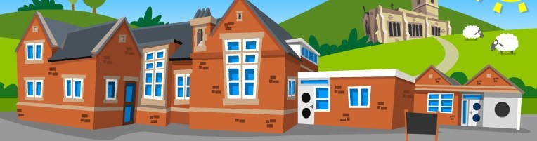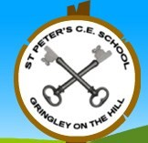
  Curriculum Overview
  Summer 1
  Class 1— Year 1/2
English
Year 1 will continue their daily Read Write Inc lessons. Resources for you to support your child at home ready for the National Phonics screening check will be sent home this half term.
Year 2 will have a daily spelling lesson as well as SPAG sessions which will include guided reading comprehensions plus daily KS1 grammar and punctuation focus.
As a class, we will continue to have our daily Talk for Writing. This half term we are learning the story of Little Red Riding Hood with a focus on writing for suspense and dialogue.

Maths
Maths, at St. Peter’s, is taught using the White Rose Maths approach, which focuses on maths mastery—children are taught to fully grasp topics, not just scrape the surface, so by the time they move on to more advanced lessons they have a deep understanding of foundational concepts.
This half term, we will focus on:
-Shape
-fractions
-multiplication and division
-position and direction

Geography —
In this block, the children will learn the 4 countries of the UK, the 4 capital cities and the seas that surround the UK.

Art and Design—
Collage and Textiles
In this block, pupils will create abstract collage and textile images using a range of materials. They will also make a reconstructed picture using selected images from magazines and prepared papers.

Science:
Use of Every Day Materials: Children will learn to categorise and compare materials. Select the correct material for the job according their properties. Explore absorbent and waterproof materials.
Plants: Children will learn how seeds germinate, how bulbs sprout and how to keep plants healthy so they can thrive.

Design and Technology
Pupils will learn how foods that are pre-made and processed can often be unhealthy. This block lets pupils practice skills and make food that will help improve their energy, mood and future health.
Computing- Coding
Music — Pitch 2
R.E — People of God
P.E - Athletics
P.S.H.E — Being my best

