 | 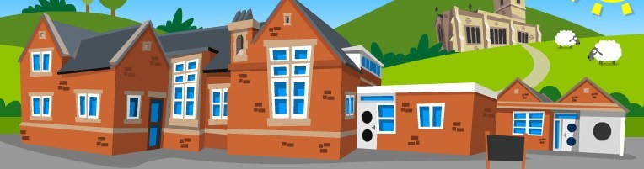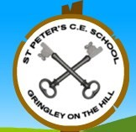
  Curriculum Overview
  Summer 2
  Class 1— Year 1/2

English
Year 1 will continue their daily Read Write Inc lessons. Thank you for continuing to work through the resources sent home in preparation for the phonics screening check.
Year 2 will have a daily SPAG sessions which will include guided reading comprehensions plus daily KS1 grammar and punctuation focus.
As a class, we will continue to have our daily Talk for Writing. This half term we have The Day the Crayons quit as our model text. We will be learning to write persuasive letters with focus on emotive language and constructing grammatically accurate sentences.
Maths
Maths, at St. Peter’s, is taught using the White Rose Maths approach, which focuses on maths mastery—children are taught to fully grasp topics, not just scrape the surface, so by the time they move on to more advanced lessons they have a deep understanding of foundational concepts.
This half term, we will focus on:
-time
-statistics
-money
-place value
-position and direction

Geography —
In this block, the children will learn about hot and cold climates in relation to the equator.

History:
We will learn about more significant individuals including: Neil Armstrong. Mae Jemison and Bernard Harris

Art and Design—
Collage and Textiles
In this block, pupils will take inspiration from the art of the indigenous people of Australia. They will combine these ideas with sculpture, creating three-dimensional forms decorated with dot patterns.

Design and Technology
In this unit, pupils will discover that they can increase the strength and stability of paper by folding. They will test and record their paper structures and design a paper tower that is at least 50cm tall and can bear a 1kg weight.
Computing-Technology all around us
Music — Introducing pitch (2)
R.E — How should we take care of others and the world?
P.E – Striking and Hitting
P.S.H.E — Growing and Changing

