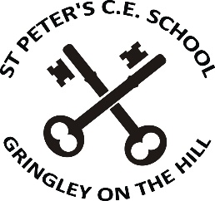
St. Peter’s C of E Primary and Nursery School
Newsletter: 13th April 2026

Dear Families of St. Peter’s,
I’d like to wish everyone a very big welcome back to school for the summer term.
I hope you had a thoroughly enjoyable Easter break and ate far too much chocolate! Reggie and Rory, my naughty dogs, thoroughly enjoyed the remainder of the Easter Sunday lamb joint that they actually stole out of the oven! Honestly, does anyone else have dogs who are capable of opening an oven door? I didn’t realise that it was even possible.
Staffing
We are welcoming Miss Blakey back to school this Wednesday following her maternity leave. She will be teaching Class 2 on Wednesday, Thursday and Fridays.
Mrs Green will be teaching maths in classes 1 and 2 alongside Miss Blakey, Miss Adams and Mrs Tasker, and she will also continue to teach a Read, Write Inc group.
Mrs Chester will not be returning as the teaching assistant in class 2, but we would like to wish her lots of luck in her new venture.
School Dinners Menu
Apologies for the Summer term school meals menu being missing from the school website yesterday. I have included a paper copy of the menu along with this newsletter; I appreciate that this is not going to help this week but it should do going forward.
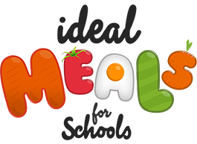
Please note that from the Autumn term 2026, the school meals will be provided by IDEAL MEALS. There will be a choice of 3 hot meals including a vegetarian option, a jacket potato or a baguette. In addition, salad bar and bread will be available. Dessert choices will include a pudding, yoghurt or fruit. M More details will be sent out after half term.

Following a significant amount of complaints about table manners from staff, we will be keeping a very close eye on the children at lunchtimes and re-introducing the ‘Star Table.’
We will be looking for the appropriate use of a knife and fork; keeping elbows off the table; sitting on bottoms, not feet; eating with mouths closed; not rushing their food, and not using a loud voice. The children who have been noticed using good table manners, will be invited to eat at the star table (announced during Friday Celebration Assembly), at the end of the week. Location to be announced on Friday – and children, no, it’s not McDonalds!
Key Stage Two Residential Visits – meetings for families
- Class 2 visit to Hathersage meeting – Thursday 30th April straight after school
- Class 3 visit to Edale meeting – Friday 15th May straight after school


School Uniform Reminder / updates
It is really important for children to be active during their time outside. With this in mind, I have made some slight adjustments to the school uniform policy.
Grey skorts can be worn as part of the everyday uniform.
Navy blue skorts may be worn for PE.
Skorts appear to be available at a wide range of clothing shops and supermarkets.
Black trainers may be worn instead of school shoes – so long as they are COMPLETELY BLACK (including logos, soles etc)
School shoes do not withstand the rigors of football etc and many girls’ shoes are very dainty and are difficult to run around in.
Please remember that nail varnish and hair accessories in any colours other than blue or white, are not allowed.
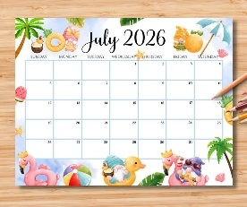
Dates for your diary
Please find a fridge-friendly sized list in this set of letters.

And finally …
I would like to think that your children attend St. Peter’s because you like our school. If you ever have any concerns or feel that you need clarification about something, please don’t hesitate to speak to your child’s class teacher, who can be found in the playground at the start and end of every school day.
I am invariably at the gate at the start and end of school (unless I’ve had knee surgery), and I am always happy to answer any questions that you may have. However, please bear in mind that if you have a question relating to a particular class, I may not be able to help you. I hope that you and your children have a very successful and enjoyable summer term with us at St. Peter’s.

Yours sincerely,

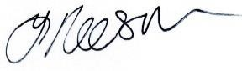
Yvonne Reeson
Head teacher

